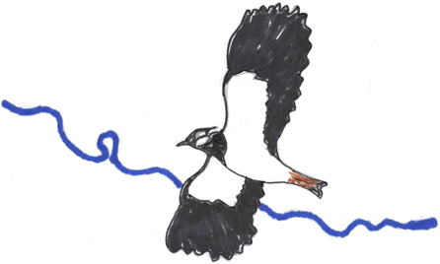

Ryburgh Wildlife Group

Sightings Record

Date seen or photographed: ____________________________________________________

Location: ____________________________________________________

Species: ____________________________________________________

Quantity: ____________________________________________________

Other comments: ____________________________________________________